DSCI 5360.007: Assignment-1
Dataset Name: USA Superstore Data
Dashboard Link: USA Sales and Profit Analysis Dashboard
Objective: I chose the US Superstore dataset because it's practical and easy to relate to. Covering the years 2014 to 2018, it contains useful details like sales, profits, customer info, and location data. This variety lets me try out different analysis skills, like spotting sales trends, seeing which products do best, or finding out which regions perform well. The dataset is also well-organized and straightforward, so it's a great choice for getting comfortable with e-commerce metrics without getting overwhelmed by messy data. Overall, it's a classic example that shows how businesses can use data to make smarter decisions, like adjusting discounts or focusing on the most profitable regions.

Below are the key findings from the data I analyzed:
1. What are sales trends by region over time?
After analyzing the data, here’s what I found about sales trends by region:
- Seasonal Sales Peak: We always see a big jump in sales during the fourth quarter across all regions, probably thanks to holiday shopping and companies wrapping up their year-end purchases.
- Top-Performing Regions: The West and East regions are consistently our top performers when it comes to sales revenue.
- Regional Performance Gaps: The South region is doing pretty well with stable sales, but the Central region is really lagging, consistently coming in last for sales volume.
- Strategic Opportunity: The differences between regions suggest that the current strategies work best in coastal areas. There is a significant growth opportunity in the Central region, depending on the development of a new, targeted approach.

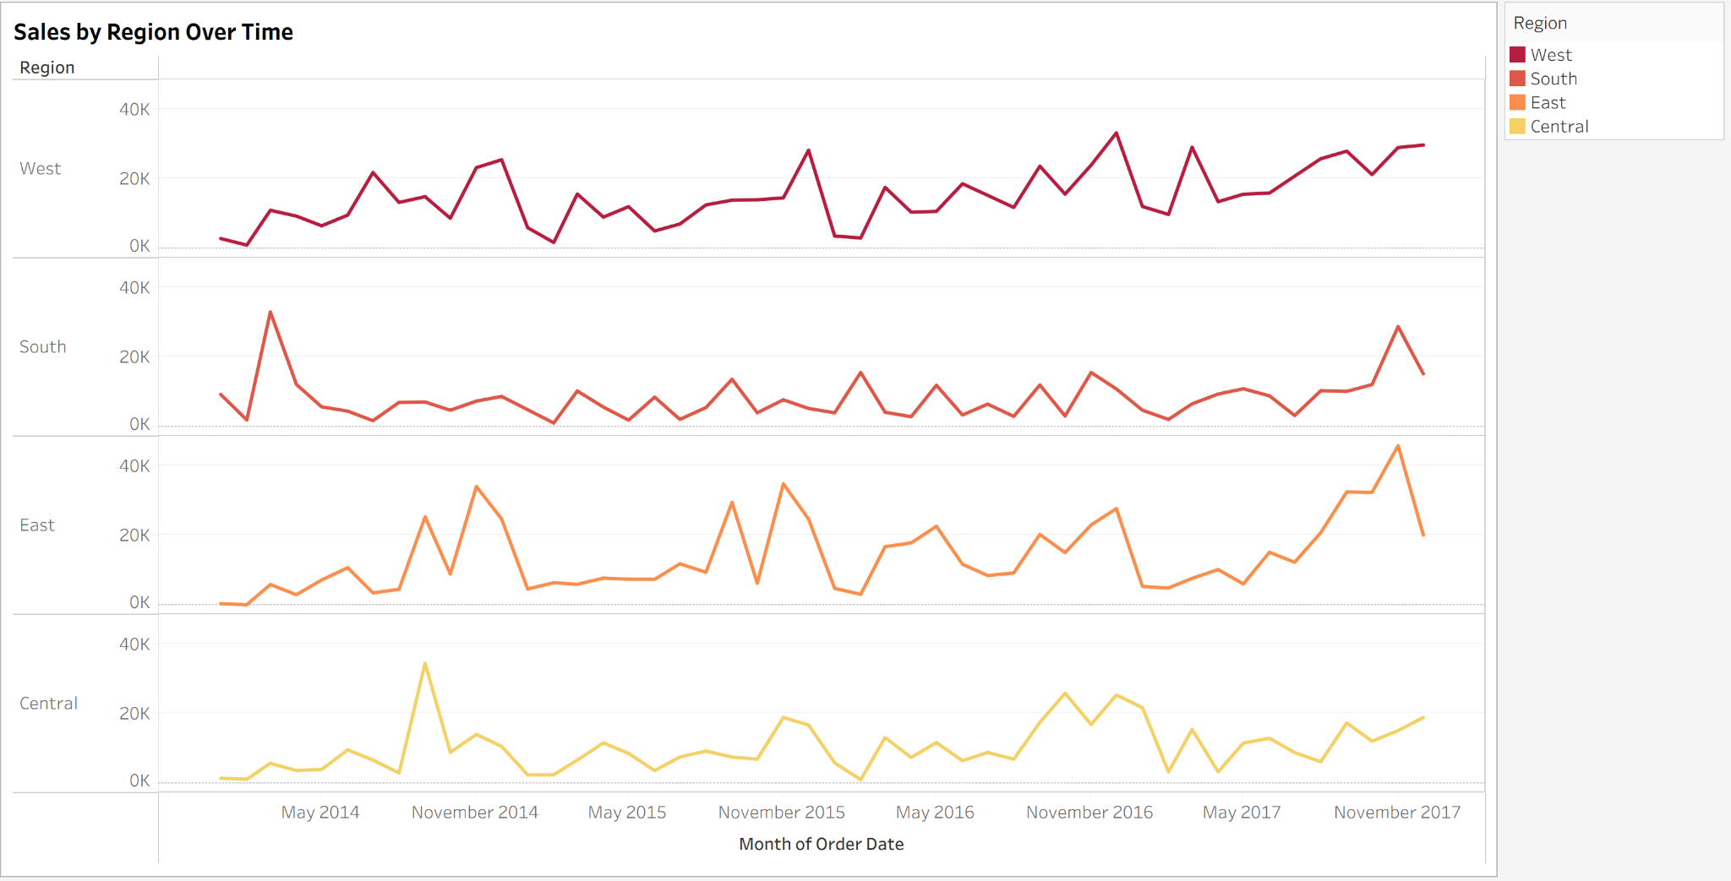

2. Which product categories generate the most profit?

Based on the provided bar chart, here are the product categories ranked by their total profit:
- Technology: This category is the most profitable, with a total profit of over 140K. This suggests that products like phones, accessories, and copiers are highly successful.
- Office Supplies: This is the second most profitable category, with a total profit of just over 120K.
- Furniture: This is the least profitable category, with a total profit of less than 20K, significantly lower than the other two.
The analysis clearly shows that Technology and Office Supplies are the key drivers of profit, while Furniture is underperforming. To improve overall profitability, it would be beneficial to look into the specific sub-categories within Furniture and their respective sales and discounts to figure out the reasons for low profit margins.

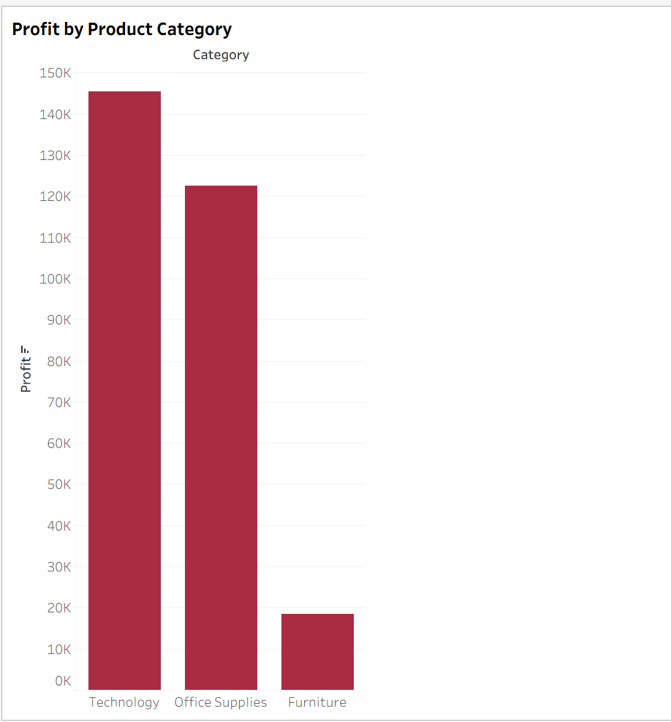

3. How do sales and profit vary across US regions and states?

This provides a clear visualization of sales and profit across the United States.
- Sales: Represented by the size of the circles. Larger circles indicate higher sales. States with the highest sales include California, New York, and Washington.
- Profit: Represented by the color of the circles. A darker red color indicates higher profit, while lighter shades and negative values indicate lower or negative profit. States with high sales, such as California and New York, also show significant profit.

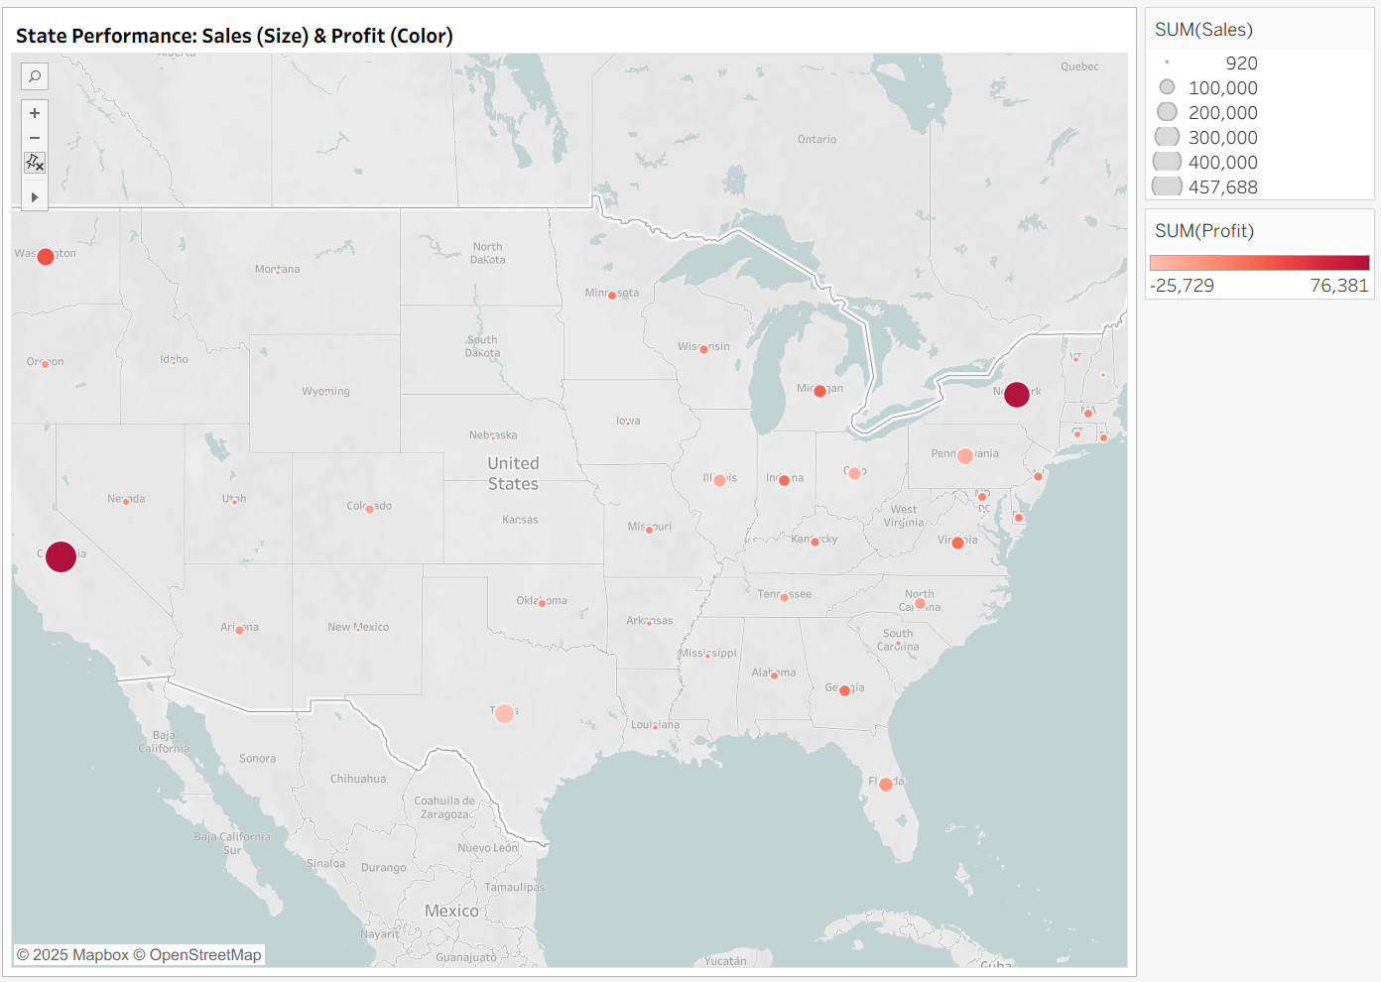

4. Which sub-categories contribute the most to overall sales within each category?

Based on the visualization

Furniture
- Chairs are the top-selling sub-category, generating the highest sales.
- Tables follow as the second-highest contributor.

Office Supplies
- Storage is the leading sub-category, with Binders and Appliances also contributing significantly to sales.
- The remaining sub-categories like Paper, Supplies, and Art, have much lower sales.

Technology
- Phones are the top-selling sub-category in the Technology category.
- Machines are the second-highest contributor, followed by Accessories and Copiers.

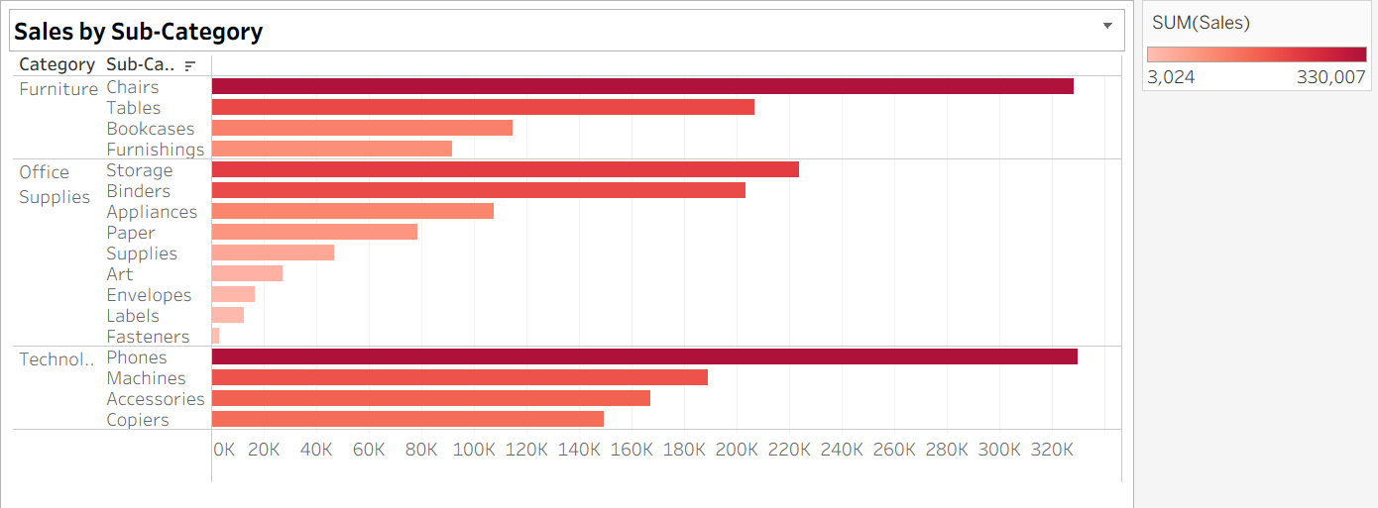

My final dashboard presents the analyzed data in a visually appealing and insightful manner.

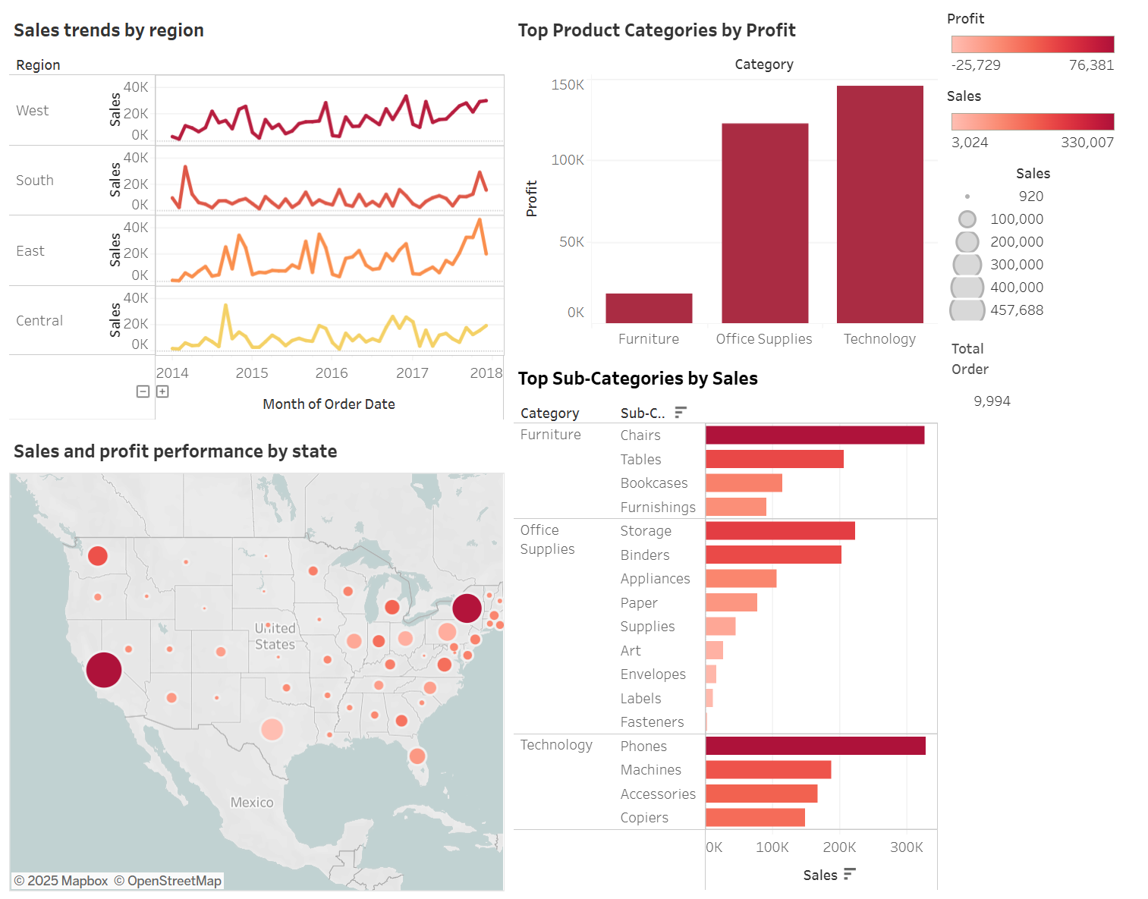

5. Which customers are regular/loyal over the years?

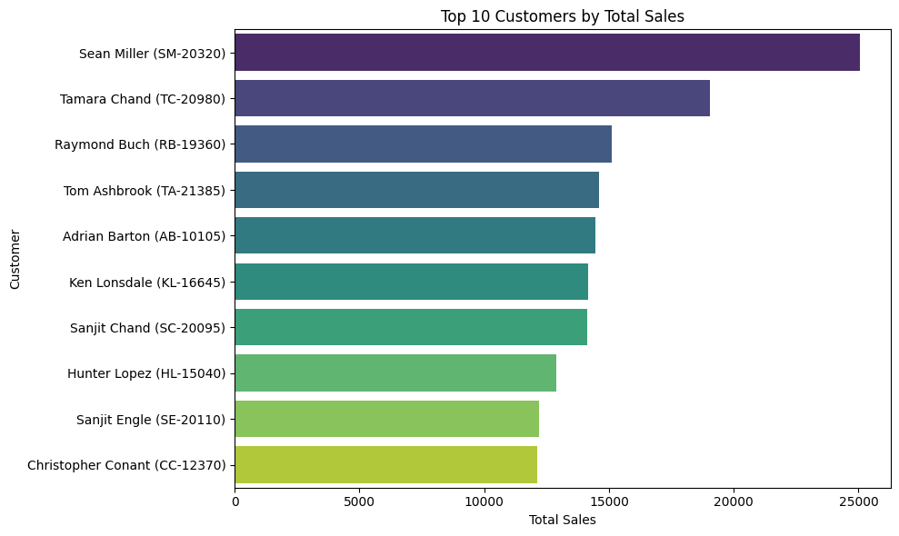

Based on the chart provided, the most loyal customer is Sean Miller (SM-20320).
The chart ranks customers by their total spending, which is a common way to measure loyalty. Sean Miller has the highest total sales, amounting to approximately $25,000, making him the top customer according to this data. Other highly loyal customers include Tamara Chand and Raymond Buch, who are ranked second and third, respectively.

AI Prompt: The Python code for the visualization was initially drafted using an AI assistant (GitHub, 2025) and then refined for clarity.
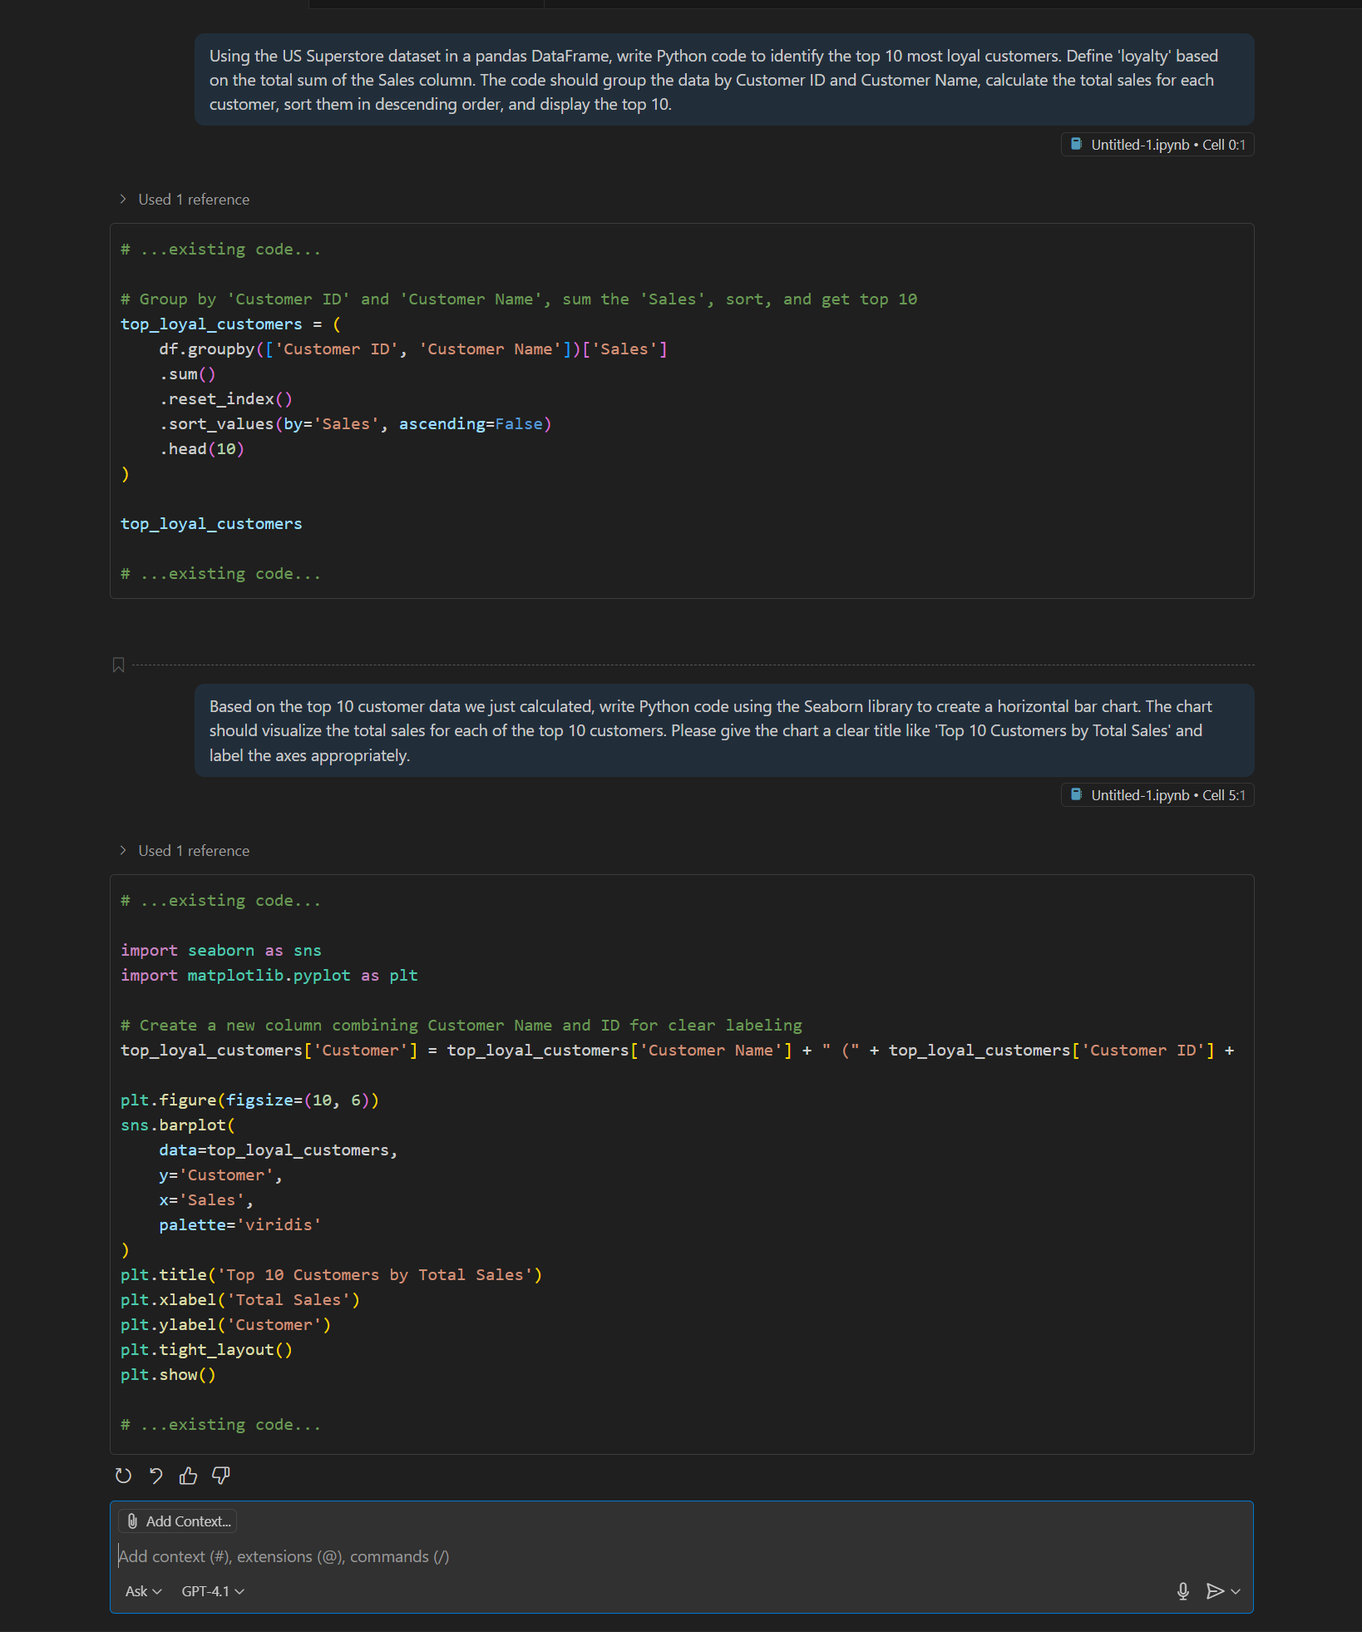
BEFORE Feedback:
This dashboard offers a complete view of US Superstore performance, visualising sales trends by region, identifying profitable product categories, and detailing state-level sales and profit, plus total sales by sub-category.
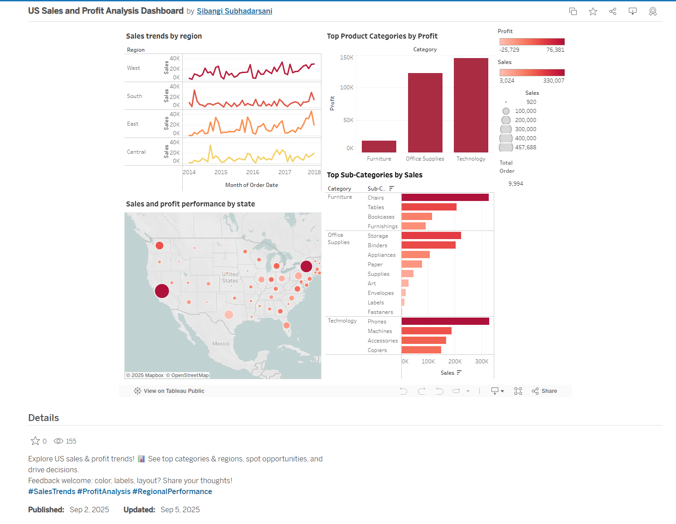
AI Prompt & Feedback:
I used Google AI (Google, 2025) tool and gave it two clear instructions to check different parts of the dashboard.
Prompted AI: 1. "Is my dashboard visually balanced and easy to scan?"
- AI Outcome: The AI provided positive feedback, confirming that the "2x2 grid layout creates a clean, organized structure with good alignment and use of white space." (Google, 2025) It noted that the clear titles and logical flow allowed for easy comprehension.
- Action Taken: No action was taken, as this feedback validated the fundamental layout of the dashboard.
Prompted AI: 2. "Are my titles and labels clear and concise? Suggest improvements."
- AI Outcome: This prompt generated critical and actionable feedback. Google AI (Google, 2025) identified three key areas for improvement:
  - Confusing Map Title: The title "Sales and profit performance by state" was deemed indirect. Google AI (Google, 2025) suggested changing it to "State Performance: Sales (Size) & Profit (Color)" to explain how to interpret the map clearly.
  - Unclear "Total Orders" Label: The label wasn't clear, and its position was confusing.
  - Inconsistent Chart Titles: The AI highlighted a lack of standardisation across different chart titles, which could lead to confusion.
- Action Taken: This feedback formed the basis for the primary structural changes to the dashboard's text and labels.

In summary, Google AI (Google, 2025) suggestions made the dashboard clearer and easier to understand because it improved the words used.
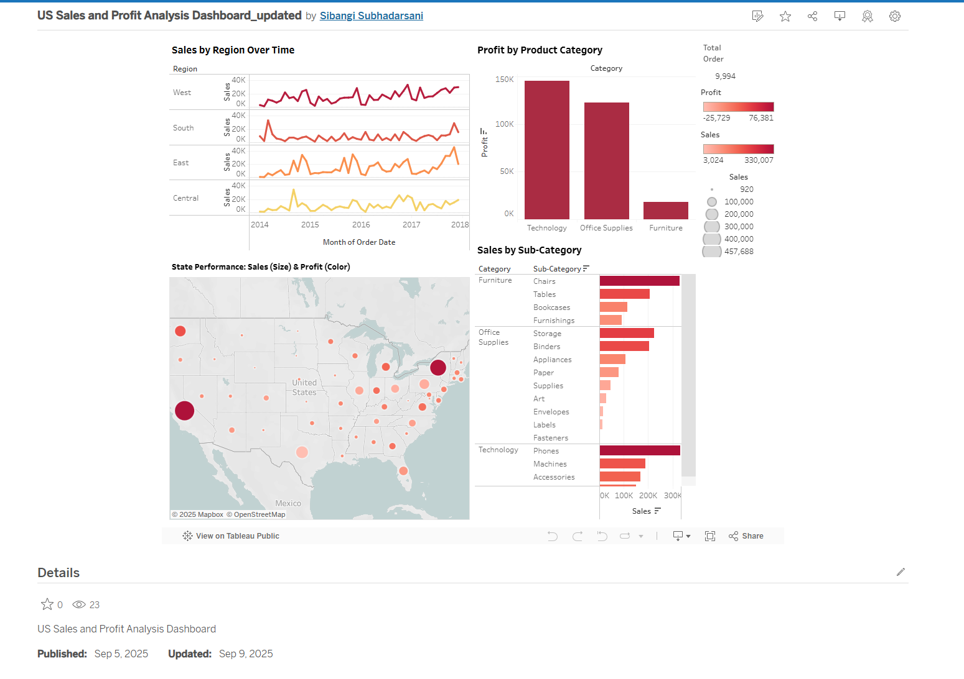

Public Tableau Community Feedback:
To get feedback from people, I posted the dashboard to the Tableau Community forum with the following prompt:
Posted Tableau: "I'd love your feedback on the design: How do you feel about the color scheme, labels, and layout? Is the dashboard visually appealing and easy to navigate? Are the titles and labels straightforward and to the point? Suggestions for improvement!"
Community Outcome: The feedback from peers corroborated and expanded upon the AI's analysis.
  - Farida Aafreen and Akash Roy pointed out that the all-red color scheme was alarming and psychologically associated with negative performance, suggesting a more neutral or positive palette.
  - Rushabh Ghanshyam Yenurkar and Radhika Bansal reinforced the AI's finding that the titles, particularly "Sales and profit performance by state," were confusing and needed to be clearer.
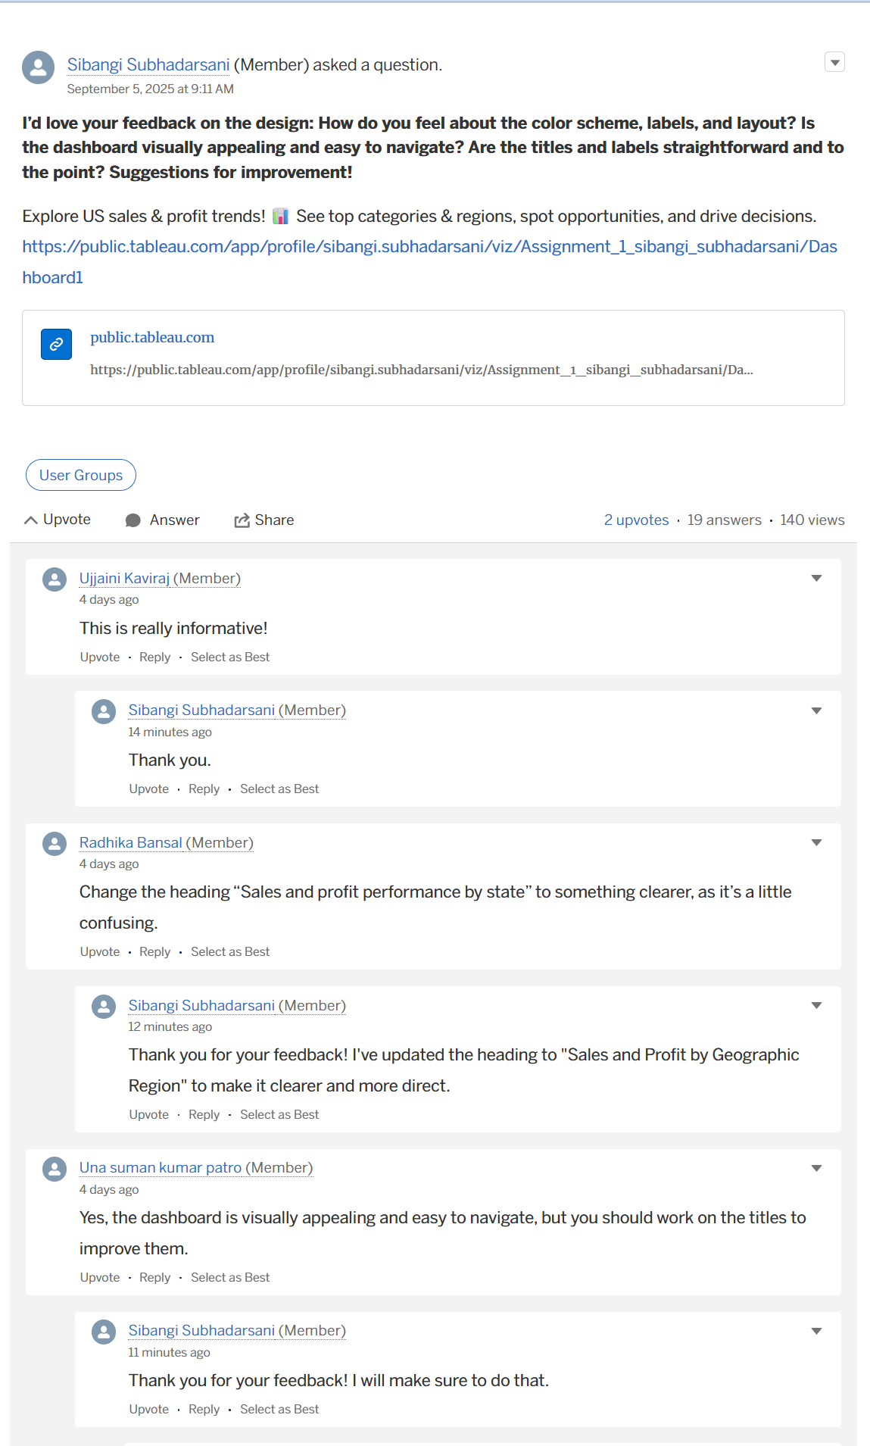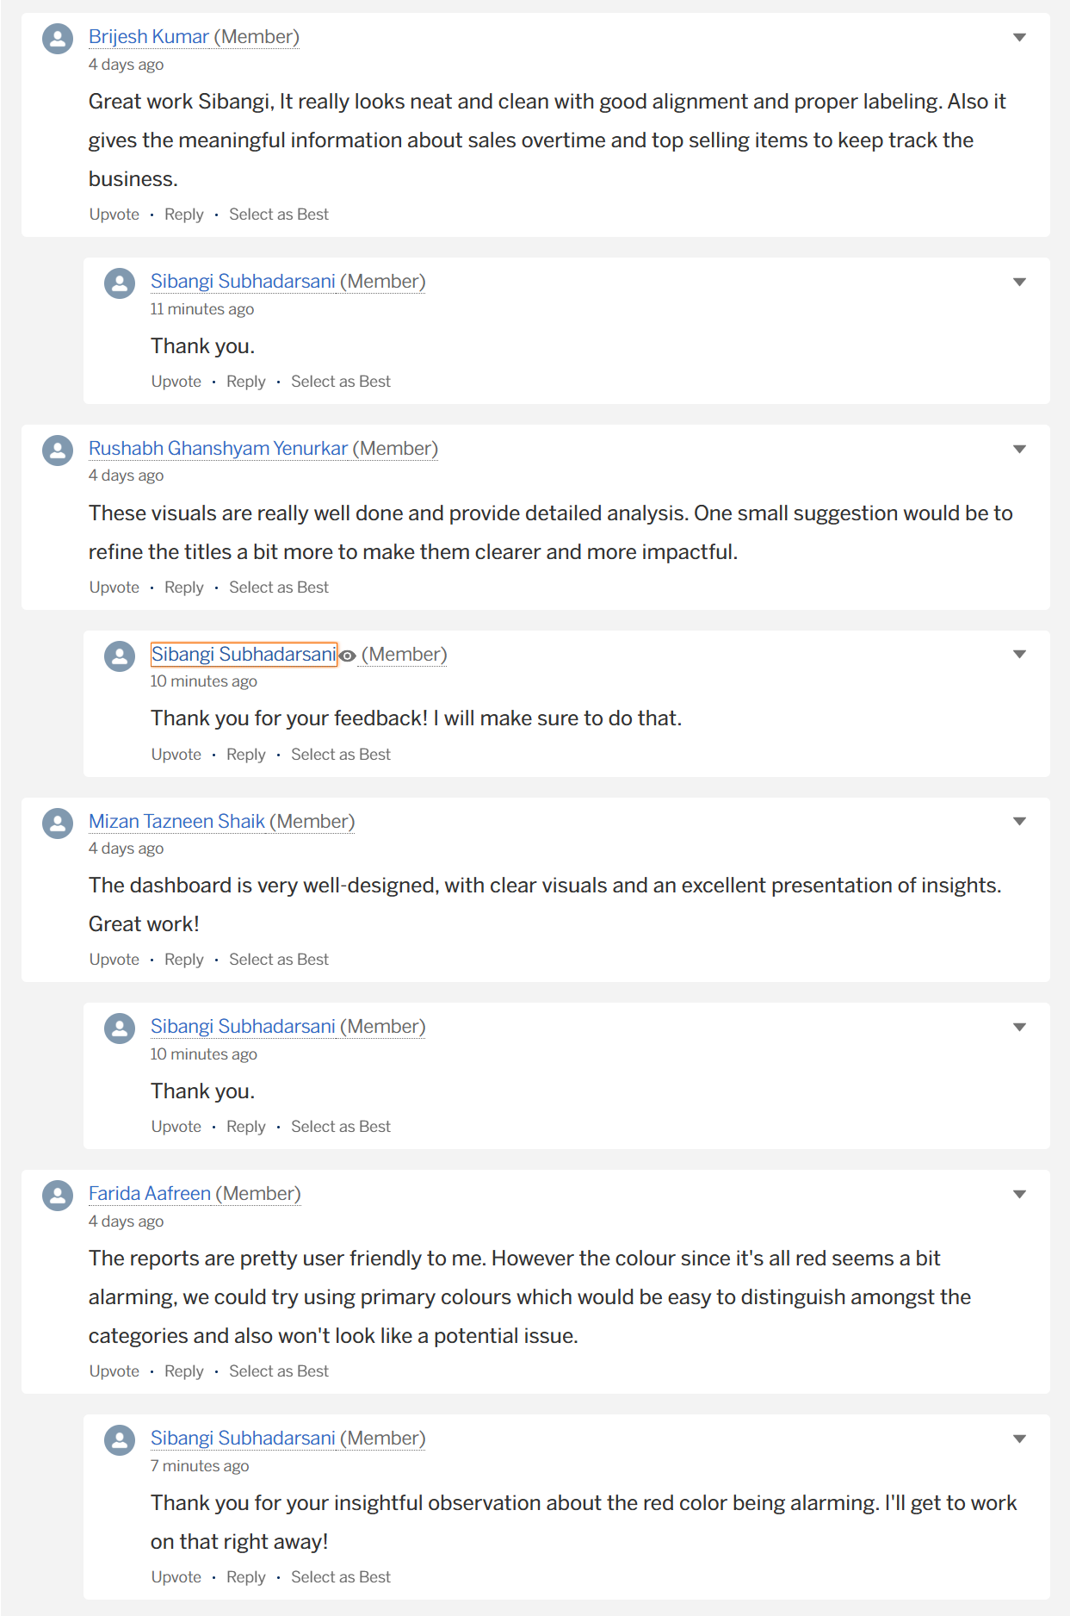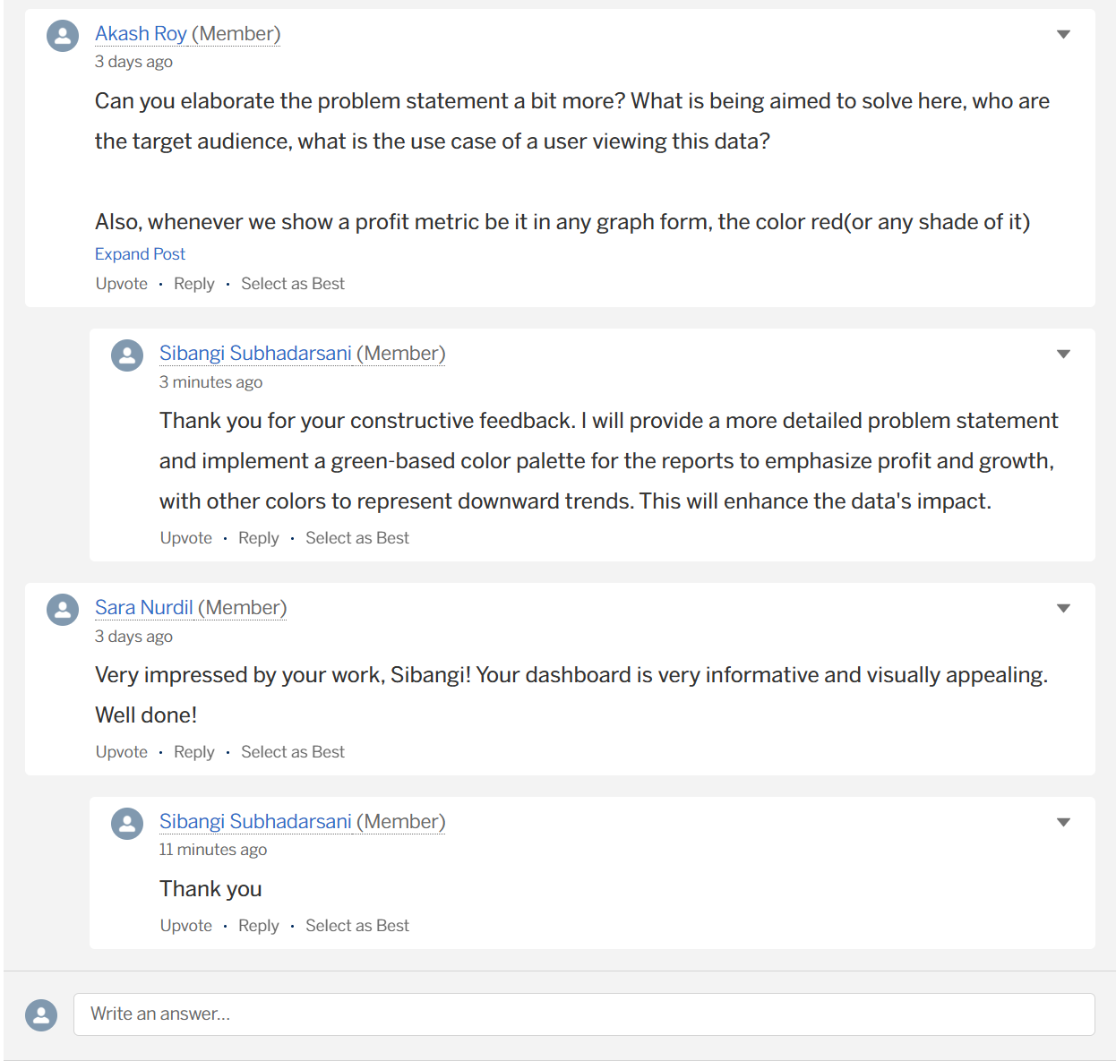

In summary, the community feedback was essential for improving the dashboard's visual design and emotional impact, making it more appealing and less likely to be misinterpreted.

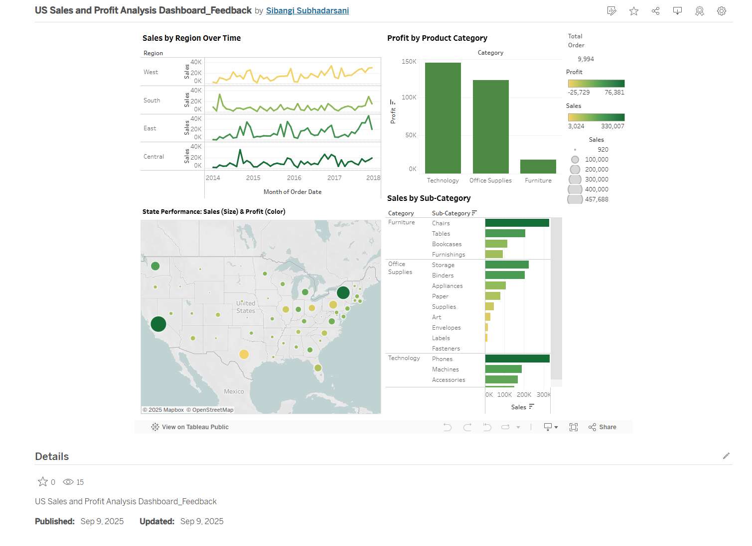

Steps Toward Final Project:

For the final project, I will incorporate the lessons learned.
- Clarity and consistency: Based on the feedback, I will make sure all titles and labels on the dashboard are clear and the same everywhere, so everyone can easily understand the data shown in each chart.
- User-Focused Color Approach: Moving forward, I will pick colors that are easy to see and don't make people think negatively. This will ensure the visual design supports the data story in a positive and informative way.
- Build a Clear Narrative Flow: I'll make the final dashboard easy to understand by showing the main points first, then more specific details, to tell a clear story.
- Enhance User Interaction: I will add ways for users to click and explore the data, like filters, so they can find information themselves.

References
- Dataset: Kaggle. (2025). US Superstore Data. Retrieved from https://www.kaggle.com/datasets/zahidmughal2343/supplement-sales-data
- GenAI Tool: Google. (2025). Gemini (Gemini 1.5 Pro). Retrieved from https://gemini.google.com
GitHub. (2025). GitHub Copilot. Retrieved from https://github.com/features/copilot
- Tableau Public: Tableau Public. (2025). https://public.tableau.com/app/profile/sibangi.subhadarsani/viz/Assignment_1_sibangi_subhadarsani/Dashboard1
- Tableau Public: Tableau Public. (2025). https://public.tableau.com/app/profile/sibangi.subhadarsani/viz/USSalesandProfitAnalysisDashboard_updated/Dashboard1
- Tableau Public: Tableau Public. (2025). https://public.tableau.com/app/profile/sibangi.subhadarsani/viz/USSalesandProfitAnalysisDashboard_Feedback/Dashboard1
- Tableau Community: Tableau Community forum. (2025). https://community.tableau.com/s/question/0D5cw00000QbqMTCAZ/id-love-your-feedback-on-the-design-how-do-you-feel-about-the-color-scheme-labels-and-layout-is-the-dashboard-visually-appealing-and-easy-to-navigate-are-the-titles-and-labels-straightforward-and-to-the-point-suggestions-for-improvement

